HTML

1. The <!DOCTYPE html> declaration defines that this document is an HTML5 document
2. An HTML element is defined by a start tag, some content, and an end tag:

<tagname> Content goes here... </tagname>

1. <html>

<head>

<title> </title>

</head>

<body>

</body>

</html>

1. HTML elements with no content are called empty elements.

The <br> tag

1. Attributes provide **additional information** about elements

Attributes are always specified in **the start tag**

Attributes usually come in name/value pairs like: **name="value"**

1. href attribute specifies the URL of the page the link goes to
2. **Absolute URL** - Links to an external image that is hosted on another website.
3. **Relative URL** - Links to an image that is hosted within the website. Here, the URL does not include the domain name. If the URL begins without a slash, it will be relative to the current page.
4. The title attribute defines some extra information about an element.

The value of the title attribute will be displayed as a tooltip when you mouse over the element:

1. The alt attribute of <img> provides an alternate text for an image
2. the HTML <pre> element defines preformatted text.

The text inside a <pre> element is displayed in a fixed-width font (usually Courier), and it preserves both spaces and line breaks

1. The HTML style attribute has the following syntax:

<*tagname* style="*property*:*value;*">

1. background-color property defines the background color
2. color property defines the text color
3. font-family property defines the font to be used for an HTML element:
4. The HTML <b> element defines bold text, without any extra importance.
5. The HTML <strong> element defines text with strong importance. The content inside is typically displayed in bold.
6. The HTML <mark> element defines text that should be marked or highlighted
7. The HTML <del> element defines text that has been deleted from a document. Browsers will usually **strike a line through** deleted text:
8. The HTML <sub> element defines subscript text. Subscript text appears half a character below the normal line
9. The HTML <sup> element defines superscript text. Superscript text appears half a character above the normal line

# **HTML Quotation**

1. The HTML <blockquote> element defines a section that is quoted from another source.

Browsers usually indent <blockquote> elements.

1. The HTML <q> tag defines a short quotation.

Browsers normally insert quotation marks around the quotation.

1. The HTML <abbr> tag defines an abbreviation or an acronym, like "HTML"

<p>The <abbr title="World Health Organization">WHO</abbr> was founded in 1948.</p>

1. The HTML <cite> tag defines the title of a creative work (e.g. a book, a poem

<p><cite>The Scream</cite> by Edvard Munch. Painted in 1893.</p>

1. BDO stands for Bi-Directional Override.

The HTML <bdo> tag is used to override the current text direction:

<bdo dir="rtl">This text will be written from right to left</bdo>

1. **Inline** - by using the style attribute inside HTML elements
2. **Internal** - by using a <style> element in the <head> section
3. **External** - by using a <link> element to link to an external CSS file
4. The CSS padding property defines a padding (space) between the text and the border.
5. The CSS margin property defines a margin (space) outside the border.
6. Use the HTML <link> element to refer to an external CSS file

# **HTML Links**

1. href attribute, which indicates the link's destination.
2. target="_blank"- Opens the document in a new window or tab

<a href="https://www.w3schools.com/" target="_blank">Visit W3Schools!</a>

1. **absolute URL** (a full web address) in the href attribute.
2. A local link (a link to a page within the same website) is specified with a **relative URL**
3. <a href="mailto:someone@example.com">Send email</a>

## Create a Bookmark in HTML

1. First, use the id attribute to create a bookmark:

<h2 id="C4">Chapter 4</h2>

Then, add a link to the bookmark

<a href="#C4">Jump to Chapter 4</a>

1. Use the id attribute (id="*value*") to define bookmarks in a page Use the href attribute (href="#*value*") to link to the bookmark

# **HTML Images**

1. <img> tag is empty, it contains attributes only, and **does not have a closing tag.**

## Image Floating

1. Use the CSS float property to let the image float to the right or to the left of a text: <p><img src="smiley.gif" alt="Smiley face" style="float:right;width:42px;height:42px;">  
   The image will float to the right of the text.</p>

<p><img src="smiley.gif" alt="Smiley face" style="float:left;width:42px;height:42px;">  
The image will float to the left of the text.</p>

# **Image Maps**

1. The HTML <map> tag defines an image map. An image map is an image with clickable areas.

<img src="workplace.jpg" alt="Workplace" usemap="#workmap">  
  
<map name="workmap">  
  <area shape="rect" coords="34,44,270,350" alt="Computer" href="computer.htm">  
  <area shape="rect" coords="290,172,333,250" alt="Phone" href="phone.htm">  
  <area shape="circle" coords="337,300,44" alt="Coffee" href="coffee.htm">  
</map>

--The only difference from other images is that you must add a usemap attribute

--Then, add a <map> element.

-- The name attribute must have the same value as the <img>'s usemap attribute .

-- A clickable area is defined using an <area> element.

# **Background Images**

1. CSS background-image property: <p style="background-image: url('img_girl.jpg');">
2. If you want the entire page to have a background image, you must specify the background image on the <body> element:
3. To avoid the background image from repeating itself, set the background-repeat property to no-repeat. background-repeat: no-repeat;
4. If you want the background image to cover the entire element, you can set the background-size property to cover.

Also, to make sure the entire element is always covered, set the background-attachment property to fixed:

[**https://www.w3schools.com/html/tryit.asp?filename=tryhtml_images_background7**](https://www.w3schools.com/html/tryit.asp?filename=tryhtml_images_background7)

1. background image to stretch to fit the entire element, you can set the background-size property to 100% 100%:
2. The HTML <picture> element allows you to display different pictures for different devices or screen sizes.

[**https://www.w3schools.com/html/tryit.asp?filename=tryhtml_images_picture1**](https://www.w3schools.com/html/tryit.asp?filename=tryhtml_images_picture1)

# **Favicon**

1. <head>  
     <title>MyPageTitle</title>  
     <link rel="icon" type="image/x-icon" href="/images/favicon.ico">  
   </head>
2. table cell is defined by a <td> and a </td> tag.
3. table row starts with a <tr>
4. Header- <th> tag instead of the <td> tag

|  |  |
| --- | --- |
| [<table>](https://www.w3schools.com/tags/tag_table.asp) | Defines a table |
| [<th>](https://www.w3schools.com/tags/tag_th.asp) | Defines a header cell in a table |
| [<tr>](https://www.w3schools.com/tags/tag_tr.asp) | Defines a row in a table |
| [<td>](https://www.w3schools.com/tags/tag_td.asp) | Defines a cell in a table |
| [<caption>](https://www.w3schools.com/tags/tag_caption.asp) | Defines a table caption |
| [<colgroup>](https://www.w3schools.com/tags/tag_colgroup.asp) | Specifies a group of one or more columns in a table for formatting |
| [<col>](https://www.w3schools.com/tags/tag_col.asp) | Specifies column properties for each column within a <colgroup> element |
| [<thead>](https://www.w3schools.com/tags/tag_thead.asp) | Groups the header content in a table |
| [<tbody>](https://www.w3schools.com/tags/tag_tbody.asp) | Groups the body content in a table |
| [<tfoot>](https://www.w3schools.com/tags/tag_tfoot.asp) | Groups the footer content in a table |

1. border: 1px solid black;
2. To avoid having double borders like in the example above, set the CSS border-collapse property to collapse.

1. With the border-radius property, the borders get rounded corners
2. border-radius: 10px;
3. border-style: dotted;  
   }**Diagram

   Description automatically generated with medium confidence**
4. border-color property
5. HTML tables can have different sizes for each column, row or the entire table. <table style="width:100%">
6. Column width- <th style="width:70%">Firstname</th>
7. Row height-<tr style="height:200px">
8. HTML tables can have headers for each column or row, or for many columns/rows.

## Header for Multiple Columns

1. To do this, use the colspan attribute on the <th> element:
2. caption that serves as a heading for the entire table. <caption>Monthly savings</caption>

# **HTML Table Padding & Spacing**

1. Graphical user interface, application, Word

   Description automatically generated
2. Text

   Description automatically generated
3. Graphical user interface, application, Word

   Description automatically generated
4. <th colspan="2">Name</th>
5. <th rowspan="2">Phone</th>
6. 

# **HTML Lists**

## Description Lists

1. The <dl> tag defines the description list, the <dt> tag defines the term (name), and the <dd> tag describes each term: 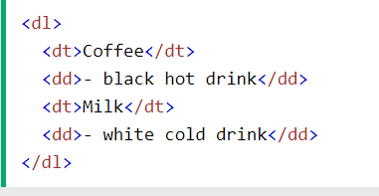
2. <ul style="list-style-type:disc;">

1. The type attribute of the <ol> tag
2. Graphical user interface, application

   Description automatically generated
3. 
4. A block-level element always starts on a new line, and the browsers automatically add some space (a margin) before and after the element.
5. A block-level element always takes up the full width available (stretches out to the left and right as far as it can).
6. Two commonly used block elements are: <p> and <div>.

## Inline Elements

An inline element does not start on a new line.

An inline element only takes up as much width as necessary.

This is a <span> element inside a paragraph.

1. Multiple HTML elements can share the same class.
2. To define multiple classes, separate the class names with a space, e.g. <div class="city main">.

# **HTML id Attribute**

1. id attribute is used to specify a unique id for an HTML element.
2. You cannot have more than one element with the same id in an HTML document.
3. An HTML iframe is used to display a web page within a web page.
4. <iframe src="*url*" title="description"></iframe>
5. The HTML <head> element is a container for the following elements: <title>, <style>, <meta>, <link>, <script>, and <base>.
6. A responsive web design will automatically adjust for different screen sizes and viewports.
7. Examples of **non-semantic** elements: <div> and <span> - Tells nothing about its content.
8. Examples of **semantic** elements: <form>, <table>, and <article> - Clearly defines its content.
9. The <nav> element defines a set of navigation links. Text, letter

   Description automatically generated
10. Html forms
11. The <form> element is a container for different types of input elements
12. Graphical user interface

    Description automatically generated with medium confidence
13. A picture containing graphical user interface

    Description automatically generated
14. 
15. 
16. Notice that each input field must have a name attribute to be submitted.
17. If the name attribute is omitted, the value of the input field will not be sent at all.
18. The action attribute defines the action to be performed when the form is submitted. 
19. If the action attribute is omitted, the action is set to the current page.
20. The target attribute specifies where to display the response that is received after submitting the form
21. Graphical user interface, application

    Description automatically generated
22. The method attribute specifies the HTTP method to be used when submitting the form data.
23. The form-data can be sent as URL variables (with method="get") or as HTTP post transaction (with method="post").
24. Graphical user interface

    Description automatically generated with medium confidence

**GET:**

1. Appends the form data to the URL, in name/value pairs
2. NEVER use GET to send sensitive data! (the submitted form data is visible in the URL!)
3. The length of a URL is limited (2048 characters)

**POST:**

1. Appends the form data inside the body of the HTTP request (the submitted form data is not shown in the URL)
2. POST has no size limitations, and can be used to send large amounts of data.
3. When autocomplete is on, the browser automatically complete values based on values that the user has entered before. Graphical user interface

   Description automatically generated with low confidence
4. Table

   Description automatically generated with low confidence
5. 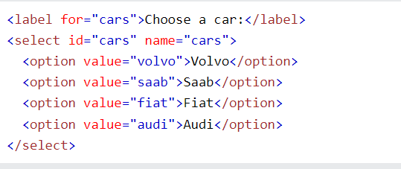
6. selected attribute to the option:

<option value="fiat" selected>Fiat</option>

1. size attribute to specify the number of visible values
2. multiple attribute to allow the user to select more than one value
3. Text

   Description automatically generated with low confidence
4. 
5. The <fieldset> element is used to group related data in a form.

The <legend> element defines a caption for the <fieldset> element.

1. Text

   Description automatically generated
2. A picture containing text

   Description automatically generated

# **HTML Input Attributes**

1. input value attribute specifies an initial value
2. input readonly attribute
3. input disabled attribute
4. input maxlength attribute
5. 

Css

1. 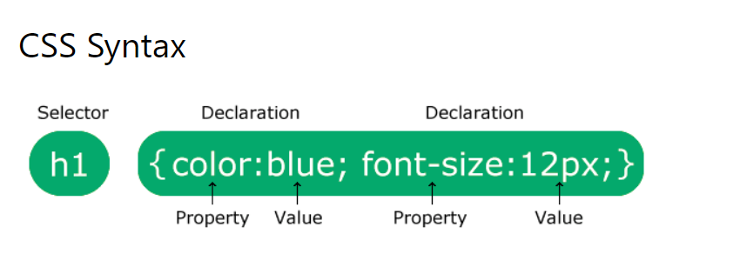
2. CSS selectors are used to "find" (or select) the HTML elements you want to style
3. Text

   Description automatically generated
4. Id selector=#
5. Class selector = dot
6. Graphical user interface, text, application

   Description automatically generated with medium confidence
7. The universal selector (*) selects all HTML elements on the page. Graphical user interface, application, Word

   Description automatically generated
8. Graphical user interface, text, application

   Description automatically generated

## External CSS

With an external style sheet, you can change the look of an entire website by changing just one file!

<link rel="stylesheet" href="mystyle.css">

## Internal CSS

An internal style sheet may be used if one single HTML page has a unique style.

## Inline CSS

An inline style may be used to apply a unique style for a single element.

1. If some properties have been defined for the same selector (element) in different style sheets, the value from the last read style sheet will be used.

## Cascading Order

1. Inline style (inside an HTML element)
2. External and internal style sheets (in the head section)
3. Browser default

# **CSS Backgrounds**

1. 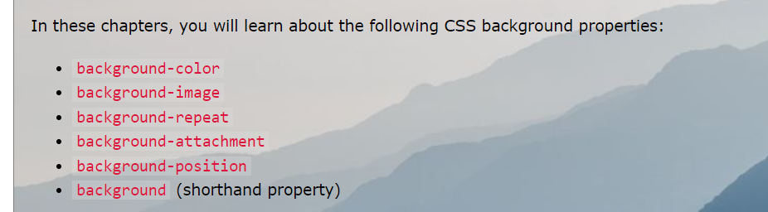
2. Graphical user interface, application, Word

   Description automatically generated
3. 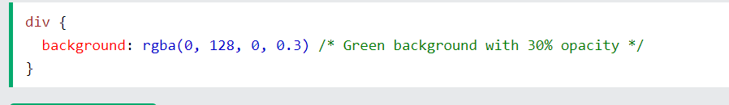
4. Graphical user interface, application

   Description automatically generated
5. By default, the background-image property repeats an image both horizontally and vertically.
6. repeated only horizontally (background-repeat: repeat-x;) Graphical user interface, text, application

   Description automatically generated
7. Graphical user interface, text, application

   Description automatically generated
8. background-position property is used to specify the position of the background image. 
9. The background-attachment property specifies whether the background image should scroll or be fixed 



1. To shorten the code, it is also possible to specify all the background properties in one single property. This is called a shorthand property. Graphical user interface, text, application, Teams

   Description automatically generated
2. Graphical user interface, text

   Description automatically generated

# **CSS Borders**

1. Graphical user interface, text

   Description automatically generated
2. 
3. 
4. Graphical user interface, text, application

   Description automatically generated

If the border-style property has three values:

1. **border-style: dotted solid double;**
   1. top border is dotted
   2. right and left borders are solid
   3. bottom border is double

## CSS Border - Shorthand Property

1. Graphical user interface, application

   Description automatically generated
2. border-radius property is used to add rounded borders

border-radius: 5px;

# **CSS Margins**

1. The CSS margin properties are used to create space around elements, outside of any defined borders. Graphical user interface, text, application, email

   Description automatically generated
2. Negative values are allowed for margin.
3. margin property to auto to horizontally center the element within its container.

## Margin Collapse

Top and bottom margins of elements are sometimes collapsed into a single margin that is equal to the largest of the two margins.

This does not happen on left and right margins! Only top and bottom margins!

# **CSS Padding**

1. Padding is used to create space around an element's content, inside of any defined borders.
2. *%* - specifies a padding in % of the width of the containing element
3. inherit - specifies that the padding should be inherited from the parent element

## Padding and Element Width

The CSS width property specifies the width of the element's content area. The content area is the portion inside the padding, border, and margin of an element ([the box model](https://www.w3schools.com/css/css_boxmodel.asp)).

So, if an element has a specified width, the padding added to that element will be added to the total width of the element. This is often an undesirable result.

1. To keep the width at 300px, no matter the amount of padding, you can use the box-sizing property. This causes the element to maintain its actual width; if you increase the padding, the available content space will decrease.
2. Graphical user interface, text, application

   Description automatically generated
3. The height and width properties do not include padding, borders, or margins. It sets the height/width of the area inside the padding, border, and margin of the element.

The height and width properties may have the following values:

* auto - This is default. The browser calculates the height and width
* length - Defines the height/width in px, cm etc.
* % - Defines the height/width in percent of the containing block
* initial - Sets the height/width to its default value
* inherit - The height/width will be inherited from its parent value

1. If you for some reason use both the width property and the max-width property on the same element, and the value of the width property is larger than the max-width property; the max-width property will be used (and the width property will be ignored).

# **CSS Box Model**

1. Table

   Description automatically generated
2. When you set the width and height properties of an element with CSS, you just set the width and height of the **content area**. To calculate the full size of an element, you must also add padding, borders and margins.
3. Total element width = width + left padding + right padding + left border + right border + left margin + right margin
4. Total element height = height + top padding + bottom padding + top border + bottom border + top margin + bottom margin

# **CSS Text**

1. The text-align property is used to set the **horizontal** alignment of a text.
2. direction: rtl;
3. unicode-bidi: bidi-override;
4. Graphical user interface, text, application

   Description automatically generated

# **CSS Text Decoration**

* text-decoration-line
* text-decoration-color
* text-decoration-style
* text-decoration-thickness
* text-decoration

1. Text

   Description automatically generated with medium confidence
2. A picture containing chart

   Description automatically generated

The Shorthand Property

The text-decoration property is a shorthand property for:

1. text-decoration-line (required)
2. text-decoration-color (optional)
3. text-decoration-style (optional)
4. text-decoration-thickness (optional)
5. The text-decoration: none; is used to remove the underline from links
6. The text-transform property is used to specify uppercase and lowercase letters in a text

In this chapter you will learn about the following properties:

1. text-indent
2. letter-spacing
3. line-height
4. word-spacing
5. white-space
6. white-space: nowrap;
7. The text-shadow property adds shadow to text.
8. In its simplest use, you only specify the horizontal shadow (2px) and the vertical shadow (2px):
9. text-shadow: 2px 2px 5px red; (x axis, y axis, blur, color)
10. The font-family property should hold several font names to ensure maximum compatibility between browsers/operating systems.
11. f you do not want to use any of the standard fonts in HTML, you can use Google Fonts.
12. Google have also enabled different font effects that you can use. A picture containing company name

    Description automatically generated
13. 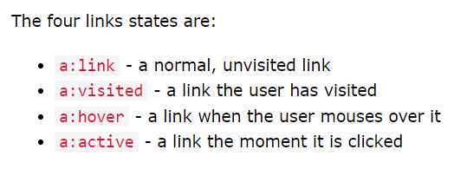
14. A picture containing chart

    Description automatically generated
15. Graphical user interface, text, application

    Description automatically generated
16. Link,visited,hover,active
17. **Tip:** The cursor: hand is often used on links.
18. Text

    Description automatically generated

# **CSS Lists**

1. list-style-type, list-style-type: circle;, : square;, : upper-roman;, : lower-alpha;
2. The list-style-image property specifies an image as the list item marker: A picture containing logo

   Description automatically generated
3. The list-style-position property specifies the position of the list-item markers (bullet points). A screenshot of a computer

   Description automatically generated with low confidence

## Shorthand

1. Graphical user interface

   Description automatically generated with medium confidence

# **CSS Tables**

1. border: 1px solid;
2. width: 100%;
3. border-collapse: collapse;
4. Graphical user interface, text, application, email

   Description automatically generated
5. A picture containing graphical user interface

   Description automatically generated
6. A picture containing logo

   Description automatically generated
7. Graphical user interface, text, application

   Description automatically generated

# **Responsive Table**

1. A picture containing shape

   Description automatically generated
2. 

# **CSS Layout - The display Property**

1. The default display value for most elements is block or inline.
2. A block-level element always starts on a new line and takes up the full width available Text

   Description automatically generated with medium confidence
3. An inline element does not start on a new line and only takes up as much width as necessary. 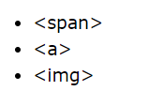
4. 
5. Hiding an element can be done by setting the display property to none. The element will be hidden, and the page will be displayed as if the element is not there:
6. visibility:hidden; also hides an element.

However, the element will still take up the same space as before. The element will be hidden, but still affect the layout:

# **CSS Layout - width and max-width**

1. Setting the width of a block-level element will prevent it from stretching out to the edges of its container.
2. The problem with the <div> above occurs when the browser window is smaller than the width of the element. The browser then adds a horizontal scrollbar to the page.
3. Using max-width instead, in this situation, will improve the browser's handling of small windows. This is important when making a site usable on small devices:
4. Max-width property is much better than width property for responsive web design so use max-width

# **CSS Layout - The position Property**

1. Graphical user interface, text, application, email

   Description automatically generated

## position: static;

HTML elements are positioned static by default.

Static positioned elements are not affected by the top, bottom, left, and right properties.

An element with position: static; is not positioned in any special way; it is always positioned according to the normal flow of the page:

## position: relative;

An element with position: relative; is positioned relative to its normal position.

Setting the top, right, bottom, and left properties of a relatively-positioned element will cause it to be adjusted away from its normal position. Other content will not be adjusted to fit into any gap left by the element.

1. position: fixed; is positioned relative to the viewport, which means it always stays in the same place even if the page is scrolled.
2. position: absolute; is positioned relative to the nearest positioned ancestor (instead of positioned relative to the viewport, like fixed).
3. An element with position: sticky; is positioned based on the user's scroll position
4. A sticky element toggles between relative and fixed, depending on the scroll position. It is positioned relative until a given offset position is met in the viewport - then it "sticks" in place (like position:fixed).
5. <https://www.w3schools.com/css/tryit.asp?filename=trycss_position_sticky>

# **The z-index**

1. z-index: -1;

# **Overflow**

1. overflow property controls what happens to content that is too big to fit into an area.
2. Text

   Description automatically generated



# **float and clear**

1. Text

   Description automatically generated
2. Text

   Description automatically generated
3. Graphical user interface, application

   Description automatically generated
4. Graphical user interface, text, application, chat or text message

   Description automatically generated

# **display: inline-block**

1. Compared to display: inline, the major difference is that display: inline-block allows to set a width and height on the element.
2. Also, with display: inline-block, the top and bottom margins/paddings are respected, but with display: inline they are not.
3. Compared to display: block, the major difference is that display: inline-block does not add a line-break after the element, so the element can sit next to other elements.
4. 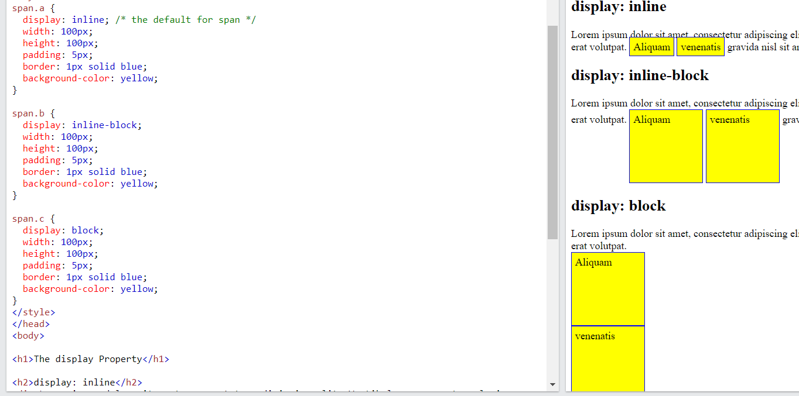
5. One common use for display: inline-block is to display list items horizontally instead of vertically.i.e navigation bar

# **Horizontal & Vertical Align**

1. To horizontally center a block element (like <div>), use margin: auto; 
2. Center aligning has no effect if the width property is not set (or set to 100%).
3. To just center the text inside an element, use text-align: center; 
4. To center an image, set left and right margin to auto and make it into a block element:

1. One method for aligning elements is to use position: absolute;: 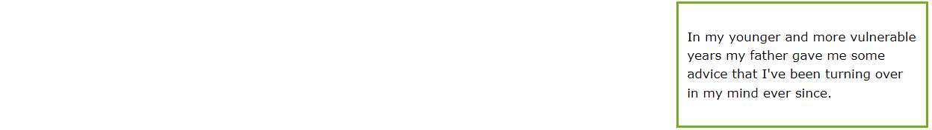

1. Another method for aligning elements is to use the float property i.e. float: right;
2. If an element is taller than the element containing it, and it is floated, it will overflow outside of its container. You can use the "clearfix hack" to fix this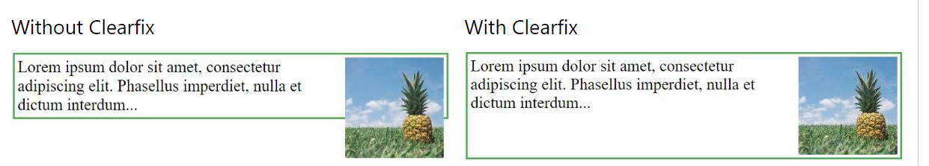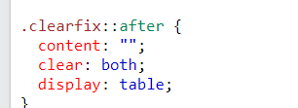

## Center Vertically - Using Flexbox

1. 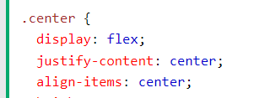

## Combinators

* A combinator is something that explains the relationship between the selectors. descendant selector (space)
* child selector (>)
* adjacent sibling selector (+)
* general sibling selector (~)

## Descendant Selector

1. Graphical user interface, application, Word

   Description automatically generated This means all paragraphs in div tag

## Child Selector (>)

1. Chart, line chart

   Description automatically generated

## Adjacent Sibling Selector (+)

1. Graphical user interface, application, Word

   Description automatically generated

## General Sibling Selector (~)

1. Graphical user interface, application, Word

   Description automatically generated

# **CSS Pseudo-classes**

1. A pseudo-class is used to define a special state of an element. Graphical user interface

   Description automatically generated
2. 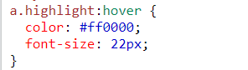
3. Hover over a <div> element to show a <p> element (like a tooltip): A picture containing graphical user interface

   Description automatically generated

## The :first-child Pseudo-class

1. 
2. A picture containing table

   Description automatically generated

# **Pseudo-elements**

A CSS pseudo-element is used to style specified parts of an element.

For example, it can be used to:

1. Style the first letter, or line, of an element
2. The ::first-line pseudo-element
3. The ::first-letter pseudo-element
4. The ::before pseudo-element can be used to insert some content before the content of an element.

1. The ::after pseudo-element can be used to insert some content after the content of an element.

# **Opacity / Transparency**

1. Chart

   Description automatically generated
2. the opacity property to add transparency to the background of an element, all of its child elements inherit the same transparency. This can make the text inside a fully transparent element hard to read: Graphical user interface

   Description automatically generated with medium confidence

## Transparency using RGBA

1. rgba(76, 175, 80, 0.3)
2. A picture containing text, plant, screenshot

   Description automatically generated

# **CSS Navigation Bar**

1. We use href="#" for test links. In a real web site this would be URLs.
2. <li><a href="#about">About</a></li>
3. list-style-type: none; - Removes the bullets.
4. Set margin: 0; and padding: 0; to remove browser default settings

## Image Sprites

An image sprite is a collection of images put into a single image.

A web page with many images can take a long time to load and generates multiple server requests.

Using image sprites will reduce the number of server requests and save bandwidth.

## CSS [attribute="value"] Selector

The [attribute="value"] selector is used to select elements with a specified attribute and value.

* 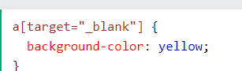input[type=text] - will only select text fields
* input[type=password] - will only select password fields
* input[type=number] - will only select number fields

## Styling Textareas

1. resize: none;

## CSS Units

1. There are two types of length units: **absolute**and **relative**.
2. Absolute length units are not recommended for use on screen, because screen sizes vary so much.
3. Pixels (px) are relative to the viewing device. Relative length units specify a length relative to another length property.

|  |  |
| --- | --- |
| em | Relative to the font-size of the element |
| rem | Relative to font-size of the root element |

## Specificity?

If there are two or more CSS rules that point to the same element, the selector with the highest specificity value will "win"

## Specificity Hierarchy

1. **Inline styles** - Example: <h1 style="color: pink;">
2. **IDs** - Example: #navbar
3. **Classes, pseudo-classes, attribute selectors** - Example: .test, :hover, [href]
4. **Elements and pseudo-elements** - Example: h1, :before

## What is !important?

1. The !important rule in CSS is used to add more importance to a property/value than normal.
2. In fact, if you use the !important rule, it will override ALL previous styling rules for that specific property on that element!
3. A picture containing graphical user interface

   Description automatically generated

# **CSS Math Functions**

1. width: calc(100% - 100px);
2. width: max(50%, 300px);
3. width: min(50%, 300px); the smallest value is chosen

## CSS border-radius Property

## **border-radius: 15px 50px 30px 5px;**

1. background: url(paper.gif);
2. The border-radius property is actually a shorthand property for the border-top-left-radius, border-top-right-radius, border-bottom-right-radius and border-bottom-left-radius properties.

# **CSS Multiple Backgrounds**

1. The different background images are separated by commas
2. background-image: url(img_flwr.gif), url(paper.gif);  
     background-position: right bottom, left top;  
     background-repeat: no-repeat, repeat;
3. background-size: 100px 80px;
4. The two other possible values for background-size are contain and cover.

## Full Size Background Image

1. background-size: cover;
2. The size can be specified in lengths, percentages, or by using one of the two keywords: contain or cover.
3. Graphical user interface, text, application

   Description automatically generated
4. The contain keyword scales the background image to be as large as possible (but both its width and its height must fit inside the content area). As such, depending on the proportions of the background image and the background positioning area, there may be some areas of the background which are not covered by the background image.
5. The cover keyword scales the background image so that the content area is completely covered by the background image

## CSS background-origin Property

1. The CSS background-origin property specifies where the background image is positioned.
2. Text

   Description automatically generated

## CSS background-clip Property

The CSS background-clip property specifies the painting area of the background.

1. Text

   Description automatically generated

## RGBA Colors

1. extension of RGB color values with an alpha channel - which specifies the opacity for a color.

## HSL Colors

HSL stands for Hue, Saturation and Lightness.

1. Hue is a degree on the color wheel (from 0 to 360):
   1. 0 (or 360) is red
   2. 120 is green
   3. 240 is blue
2. Saturation is a percentage value: 100% is the full color.
3. Lightness is also a percentage; 0% is dark (black) and 100% is white.
4. The CSS opacity property sets the opacity for the whole element (both background color and text will be opaque/transparent).

# **CSS Color Keywords**

1. The transparent keyword is used to make a color transparent
2. The inherit keyword specifies that a property should inherit its value from its parent element.-------- border: inherit;

# **CSS Gradients**

## CSS Linear Gradients

1. background-image: linear-gradient(direction, color-stop1, color-stop2, ...); 
2. A picture containing logo

   Description automatically generated
3. 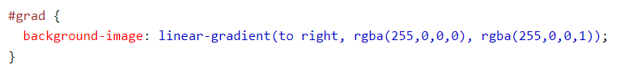
4. A picture containing text

   Description automatically generated

## CSS Radial Gradients

1. 
2. V

# **CSS Shadow Effects**

## CSS Text Shadow

1. you only specify the horizontal shadow (2px) and the vertical shadow (2px): 
2. add a blur effect to the shadow: 
3. neon glow shadow: 

## Multiple Shadows

## Graphical user interface, application Description automatically generated with medium confidenceCSS box-shadow Property

1. 
2. The inset parameter changes the shadow from an outer shadow (outset) to an inner shadow. 

# **CSS Text Effects**

## CSS Text Overflow

1. text-overflow property specifies how overflowed content that is not displayed should be signaled to the user. A picture containing chart

   Description automatically generated
2. word-wrap property allows long words to be able to be broken and wrap onto the next line. 
3. 

## CSS 2D Transforms

With the CSS transform property you can use the following 2D transformation methods:

1. translate()
2. rotate()
3. scaleX()
4. scaleY()
5. scale()
6. skewX()
7. skewY()
8. skew()
9. matrix()
10. transform: translate(50px, 100px);
11. transform: rotate(20deg);
12. transform: scale(2, 3);
13. transform: scale(0.5, 0.5);
14. transform: skewX(20deg);

# **CSS 3D Transforms**

CSS transform property you can use the following 3D transformation methods:

1. rotateX()
2. rotateY()
3. rotateZ()

# **CSS Media Queries**

1. made it possible to define different style rules for different media types.